Lab 1

Group Members: Talal Jawaid, Amrit Singh

1. Execute CashMachine. What happened?

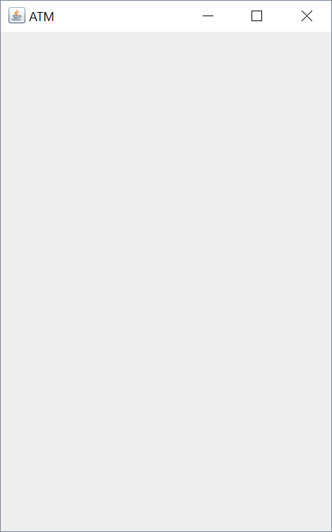

**CashMachine opened an empty box labeled ATM.**

1. Click on the icon that closes the window (which will vary with the operating system you are using). What happened? (Be careful!)

**The ATM window closed without issues. However, according to Eclipse, it was still running in the background.**

1. Terminate CashMachine
2. Add the following statement to the end of the constructor in the PINPadWindow class. setDefaultCloseOperation(JFrame.EXIT_ON_CLOSE);
3. Execute CashMachine and again click on the icon that closes the window (which will vary with the operating system you are using). What happened now?

**The ATM window now closes and the process is properly terminated.**

**Part 2.** Layout: This part of the lab will give you some experience constructing GUI components and working with layout managers.

**1.** Suppose you needed to layout a Container in a table/matrix that contains four rows and three columns. What layout manager would you use?

**I would use GridLayout because it allows you to use the requested number of rows and columns.**

**2.** Complete the setupLayout() method in the NumberPad class. Your implementation must contain 12 JButton objects and be consistent with the following wireframe.

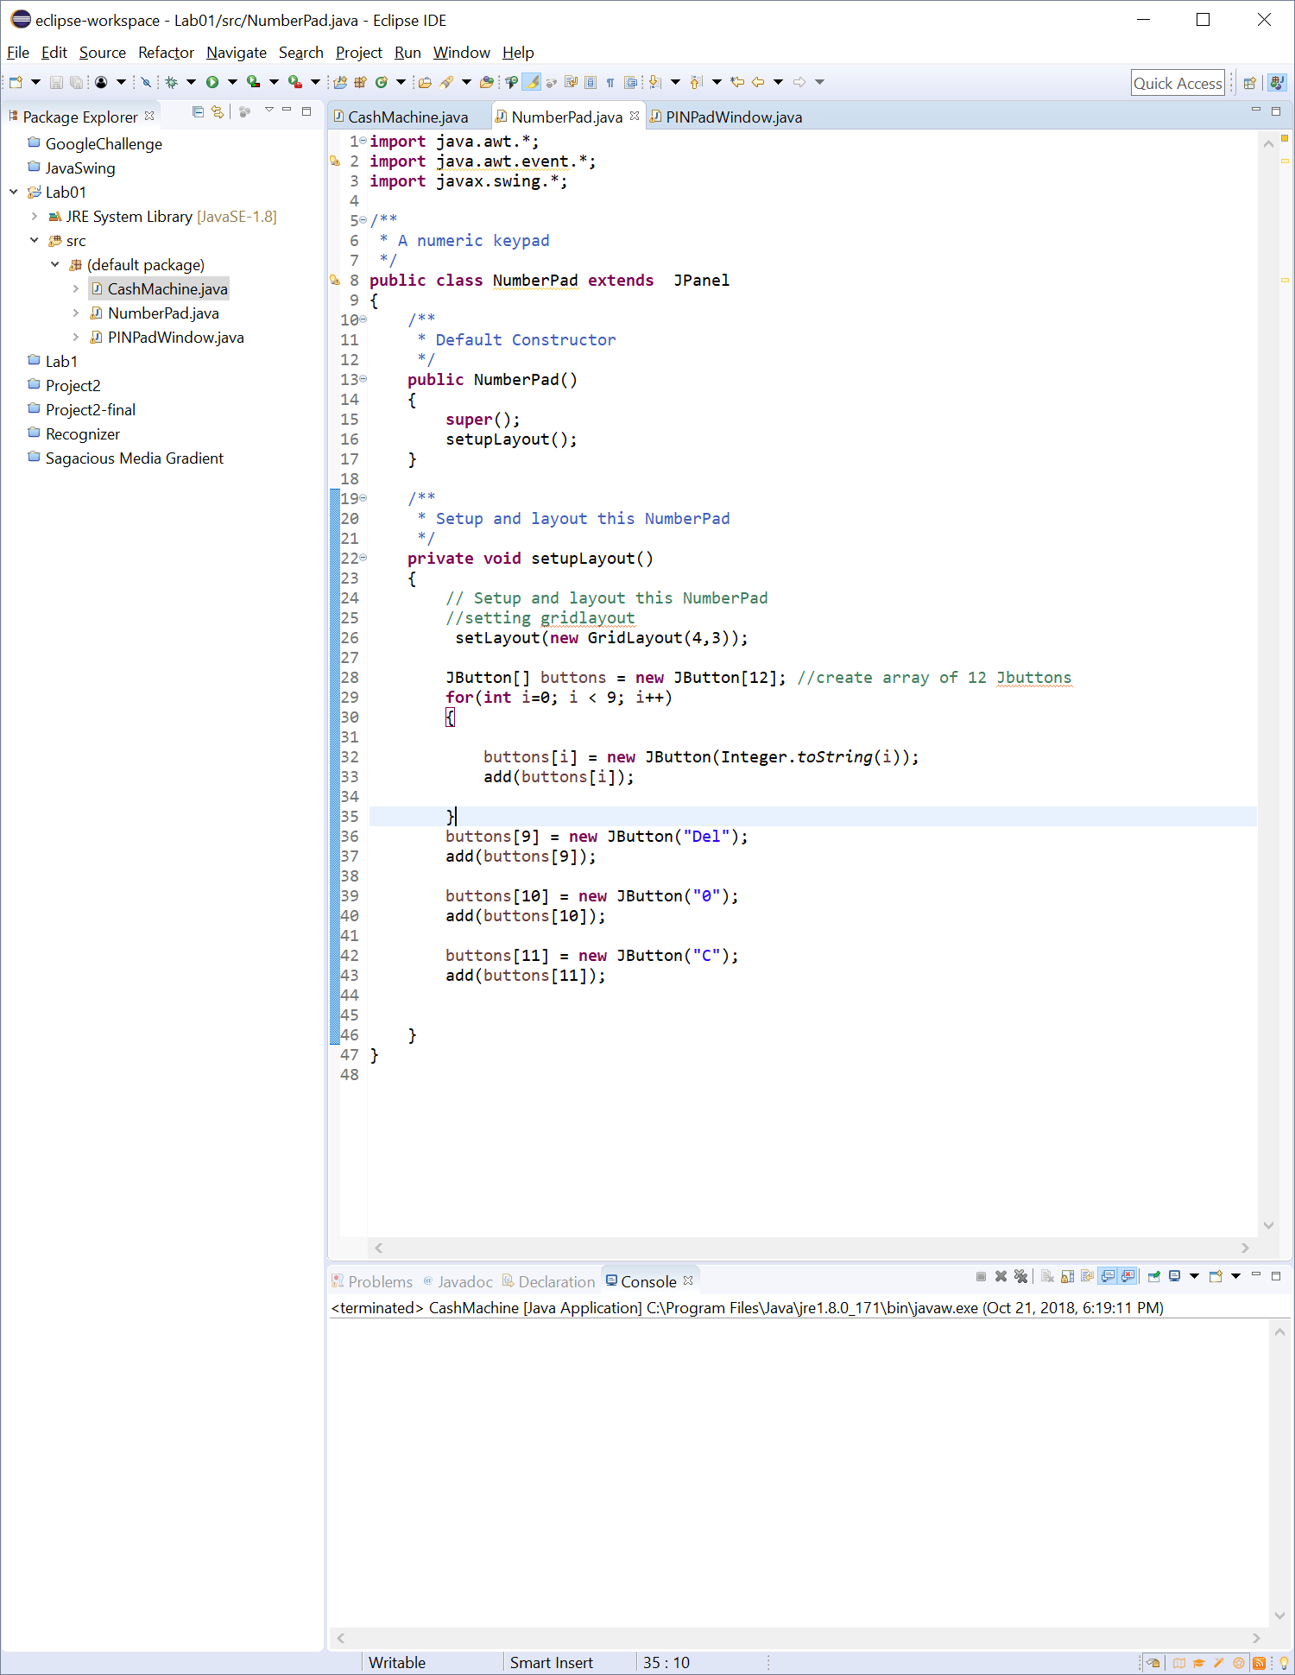

**3.** Your implementation may include duplicate code. If so, correct your implementation by adding one or more private methods (and, perhaps, a "constant"). What does your code look like now?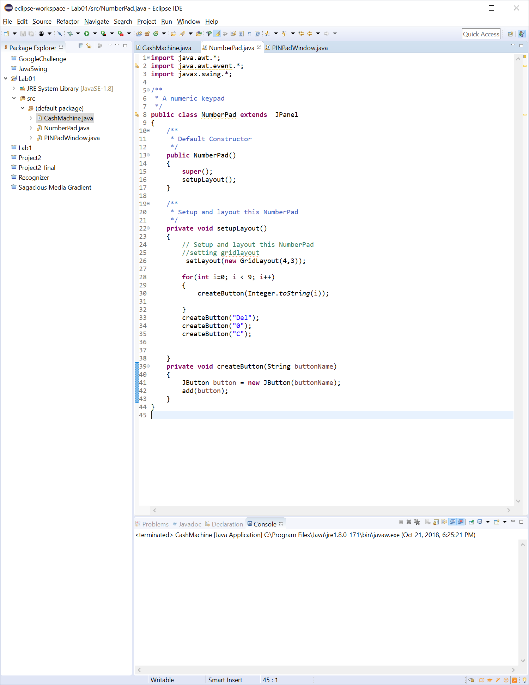

Modify the setupLayout() method in the PINPadWindow class so that it now constructs a NumberPad and adds it to the content pane. What code is in the setupLayout() method now?

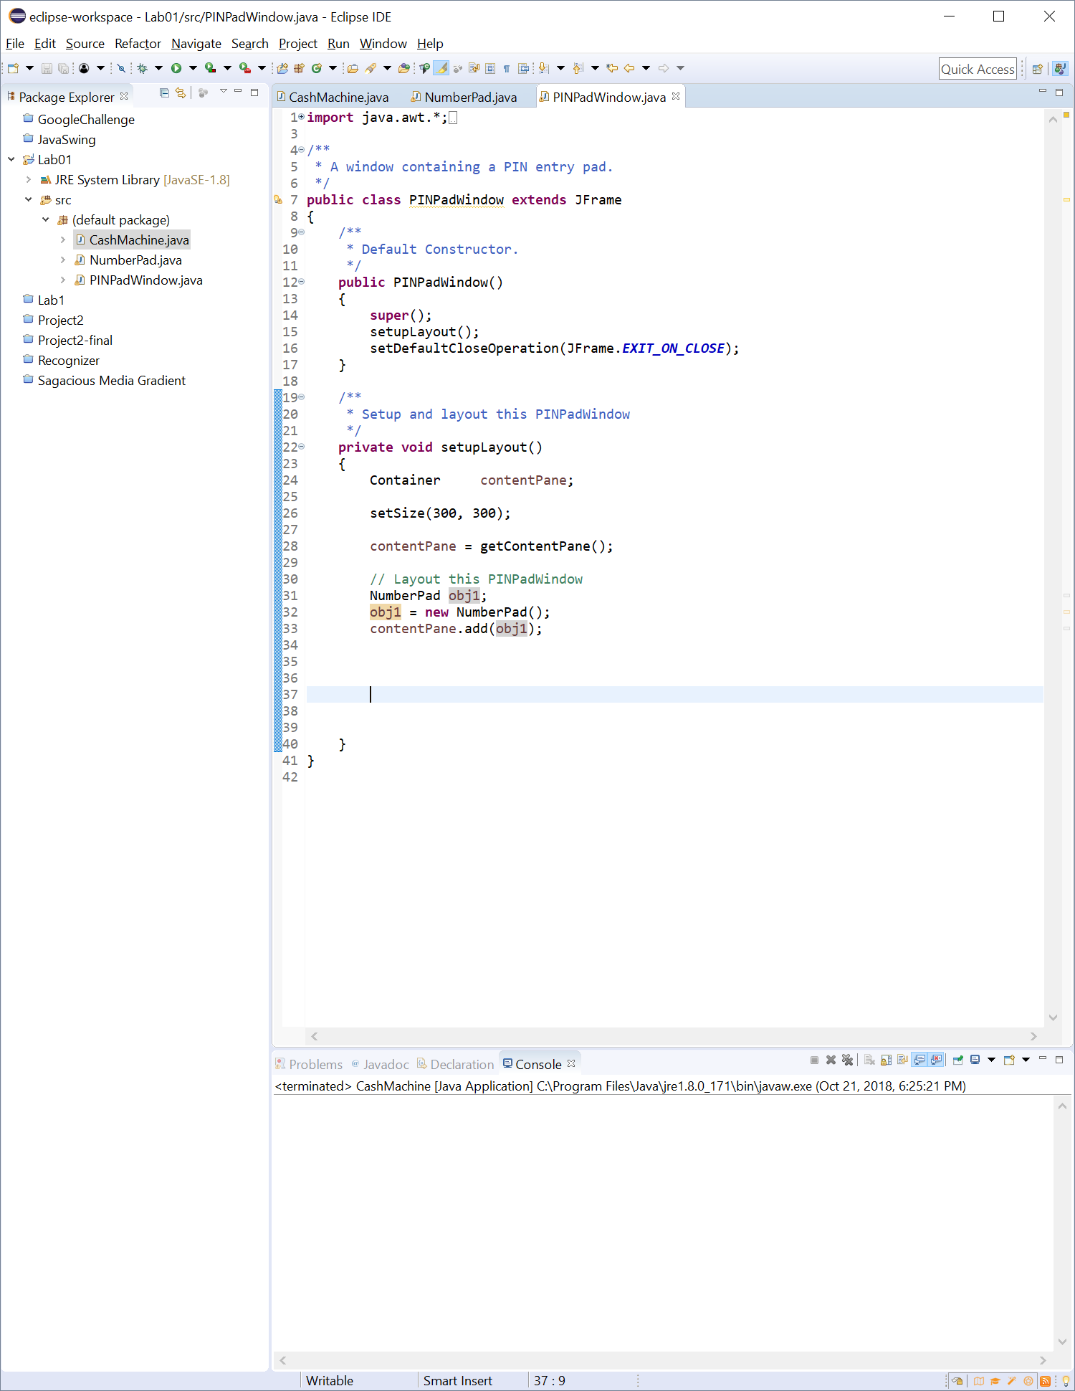

**5.** Execute CashMachine. How big is the window and how big are the buttons?

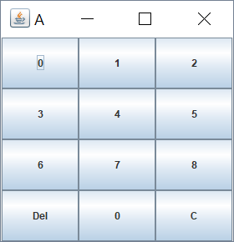

**The window is fairly small and the buttons are all equally sized.**

1. **Terminate CashMachine.**
2. Add the following to the bottom of the constructor in the PINPadWindow class. pack(); Execute CashMachine. How big is the window now?

**It’s now even smaller, I can’t even click the top to drag it because it’s so tiny.**

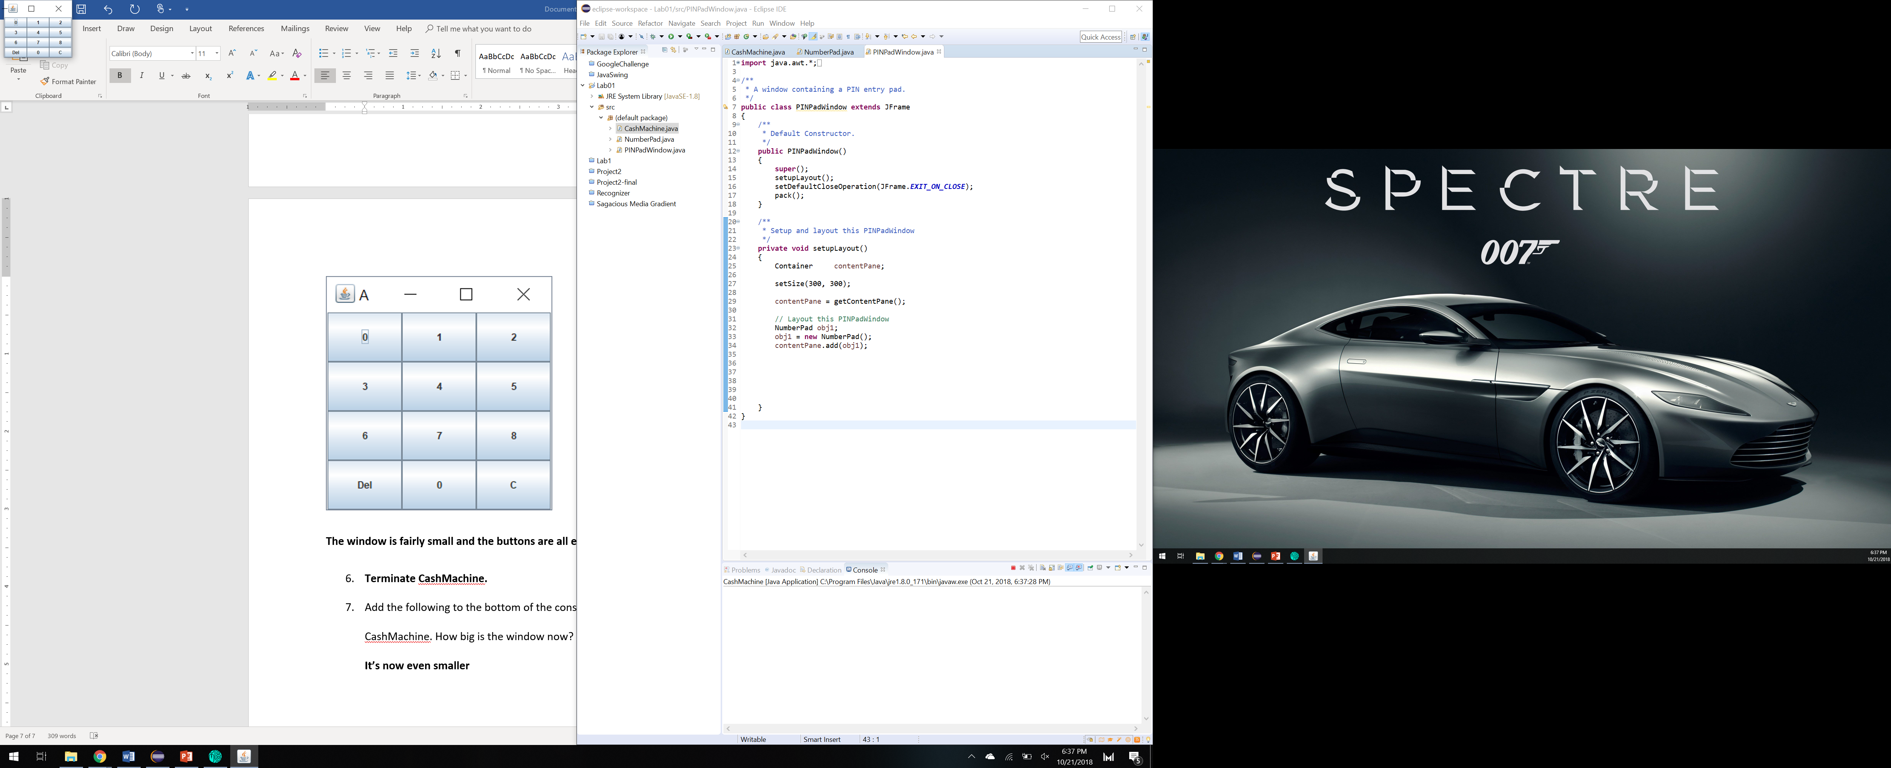

1. Resize the window. What happens and why?

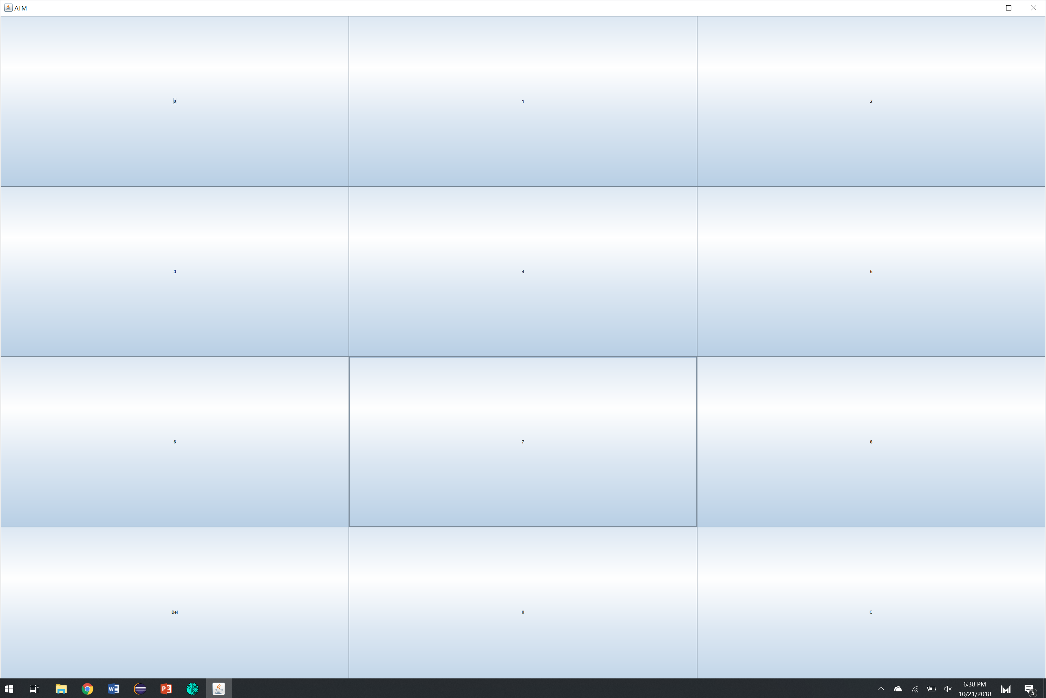

**The buttons get bigger but the text size remains the same since we did not modify the font.**

1. Add the following to the bottom of the constructor in the PINPadWindow class. setResizable(false);

Execute CashMachine. Can you re-size the window?

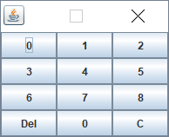

**The window is not resizable.**

**3-1.**

**Create a Display class that specializes the JLabel class. The default constructor must call the**

**single-parameter constuctor in the parent class passing it " " and then call the setBorder() method passing it an etched border**

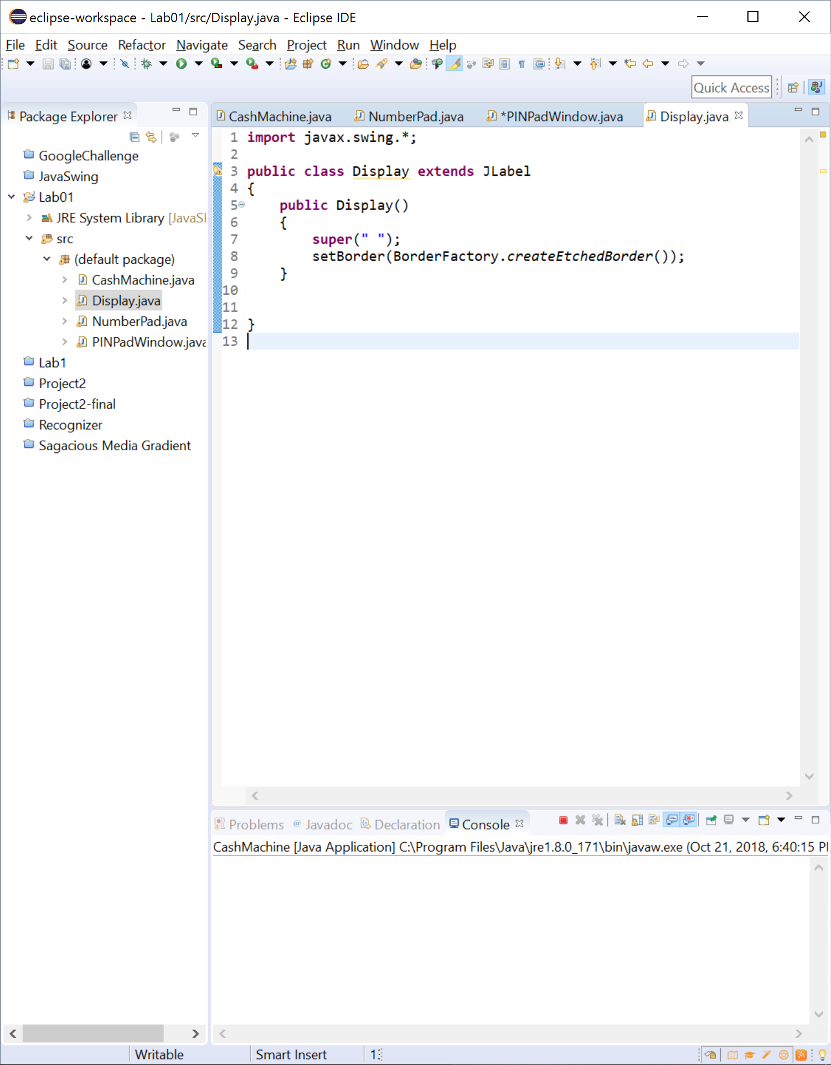

4. Modify the setupLayout() method in the PINPadWindow class so that it adds a Display above the NumberPad in a fashion that is consistent with the following wireframe. What code is in this method now? (Note: Remember to construct an appropriate layout manager and pass it to setLayout().)

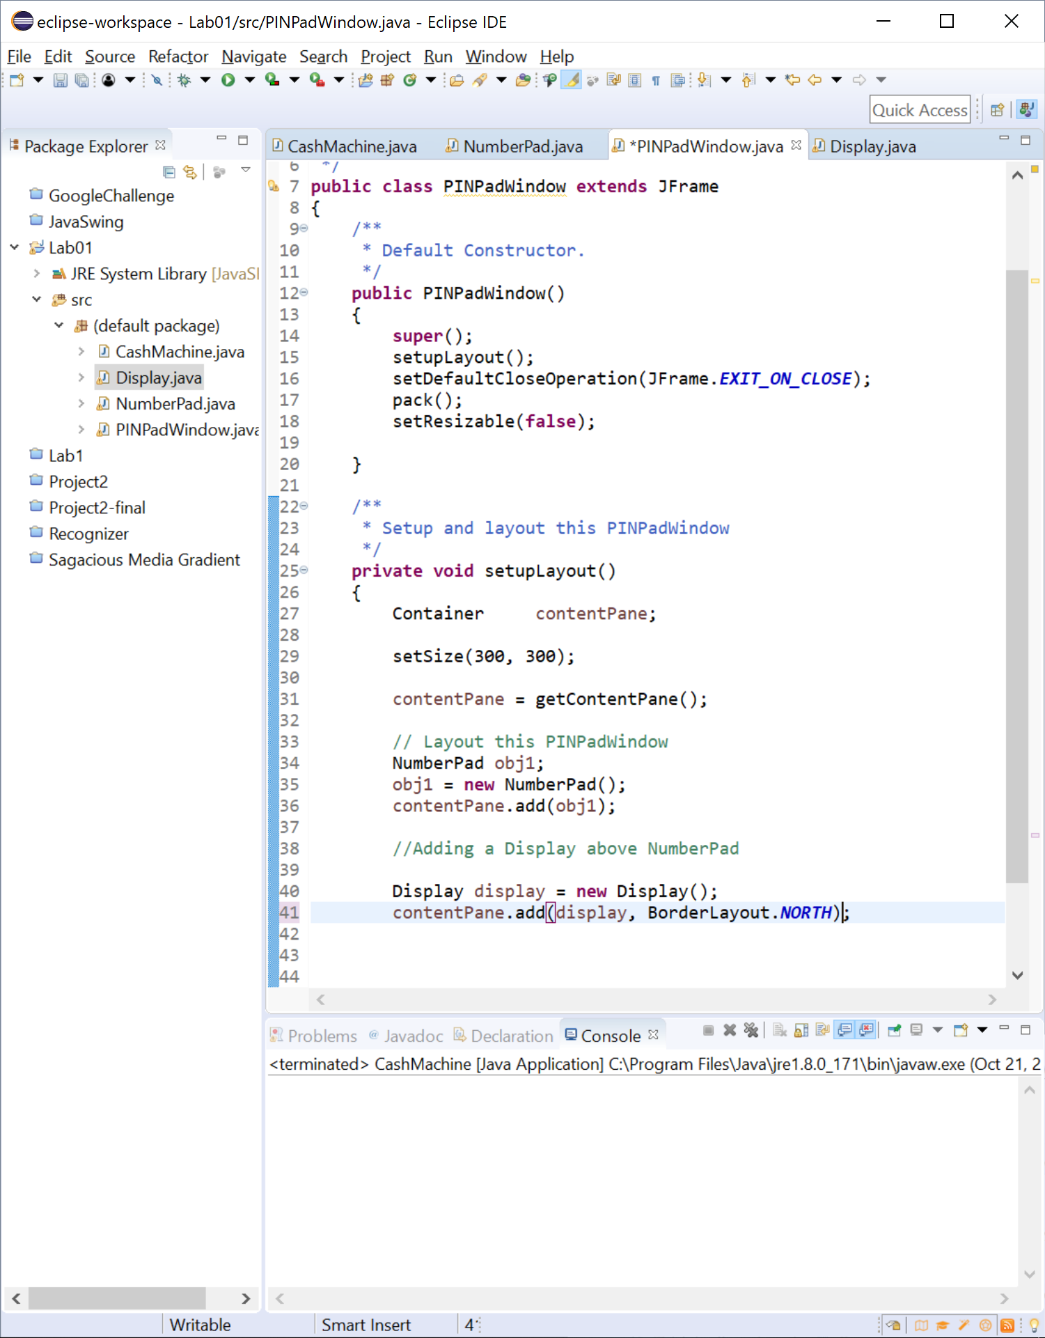

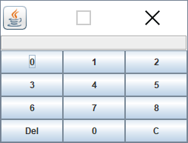

5. Modify the Display class so that it now realizes the ActionListener interface. Specifically, it should respond to ActionEvent objects that have an action command of "C" by clearing its contents (i.e., by setting its text to " ") and any other ActionEvent objects by appending the action command to its current contents. What code is in this class now?

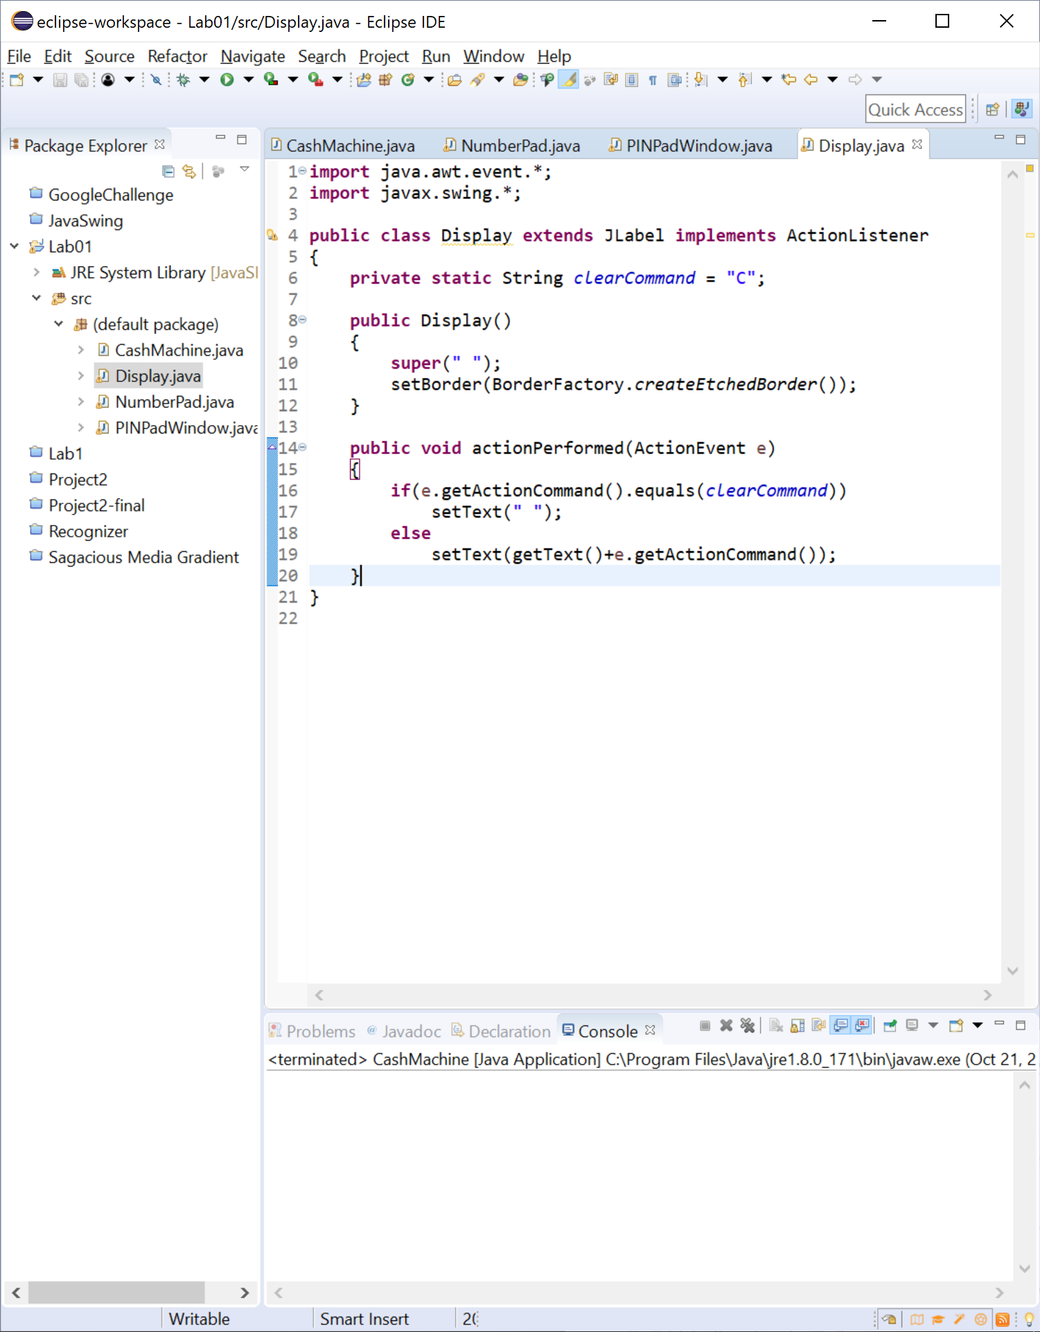

**5-2.** Modify the constructor in the NumberPad class so that it is now passed an ActionListener object that it stores in a private attribute named listener, before calling setupLayout(). What code is in the constructor now?

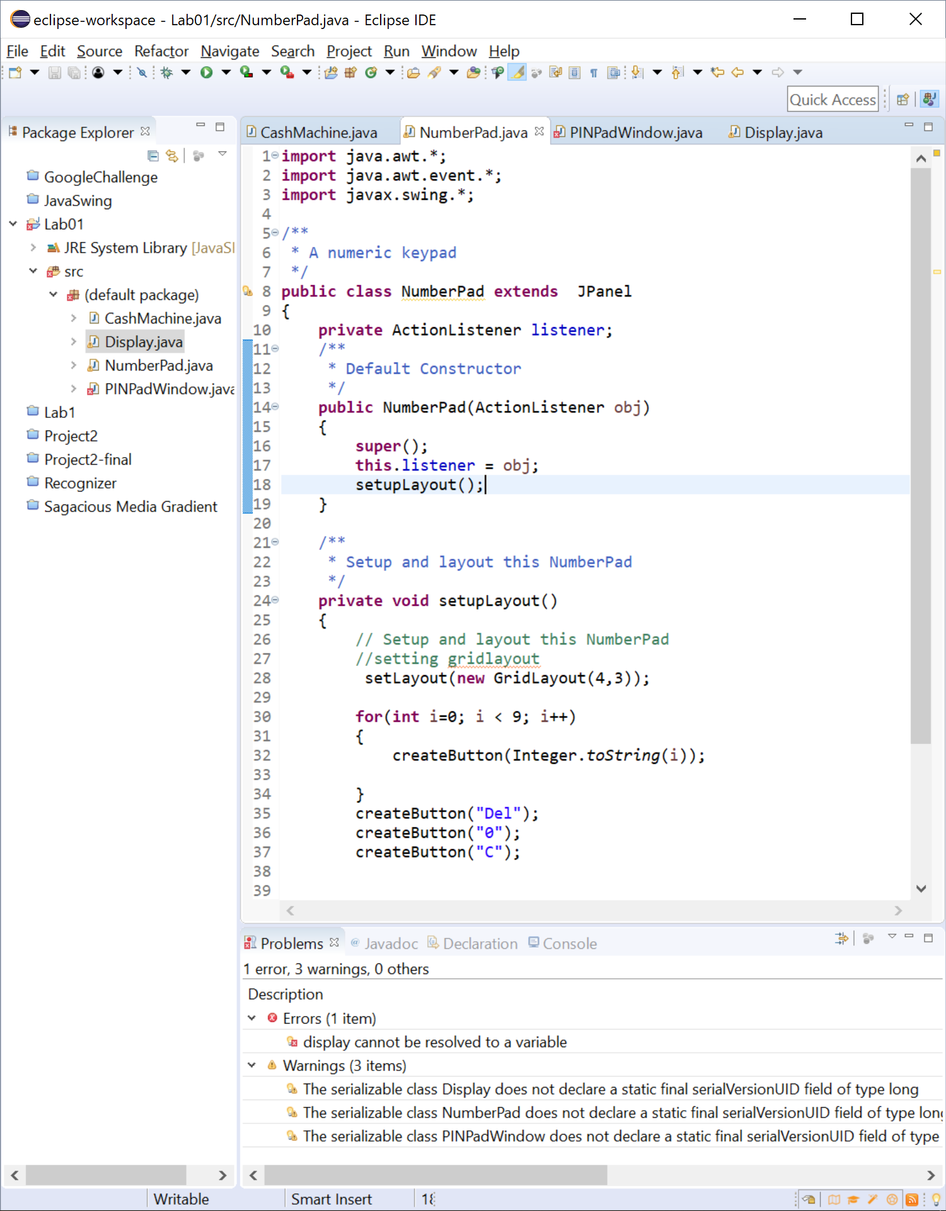

**5-3.** Modify the addButton() method in the NumberPad class so that it makes listener an ActionListener on the button it is adding. What code did you add?

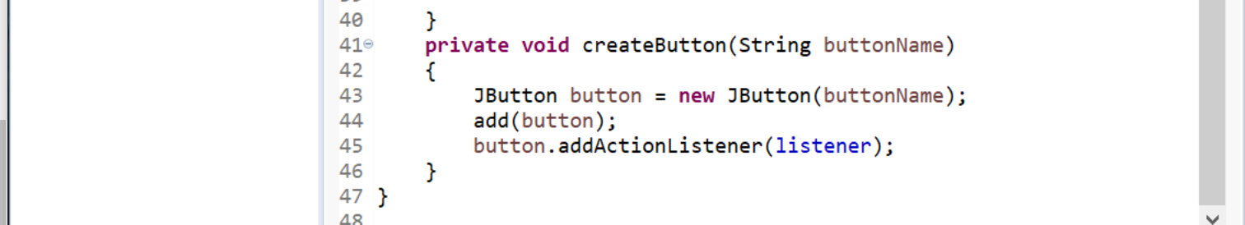

**5-4.** . Modify the setupLayout() method in the PINPadWindow class so that the Display is now an ActionListener on the NumberPad. What code did you change?

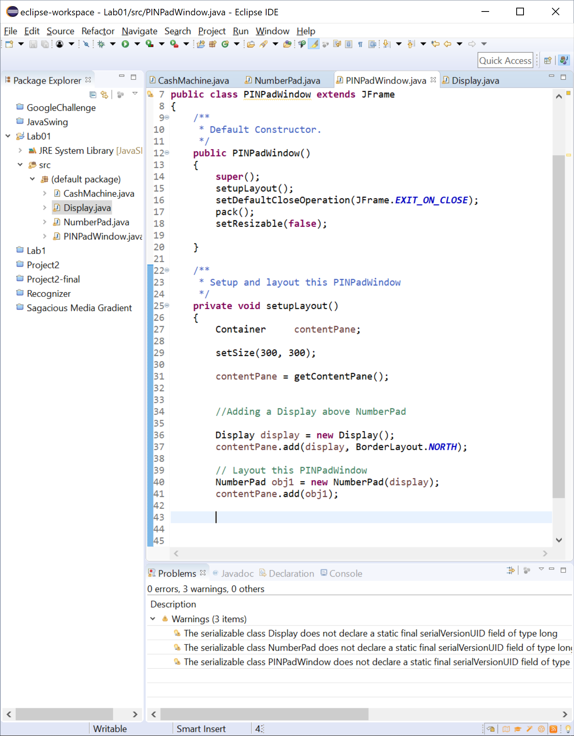

**5-5.** Execute CashMachine. What happens when you click on the various buttons?

**The numbers show up on the display when pressed, and pressing C clears the display. However, pressing DEL results in DEL showing up on the display.**

**5-6.** Modify the Display class so that the text is aligned to the right. What change did you make?

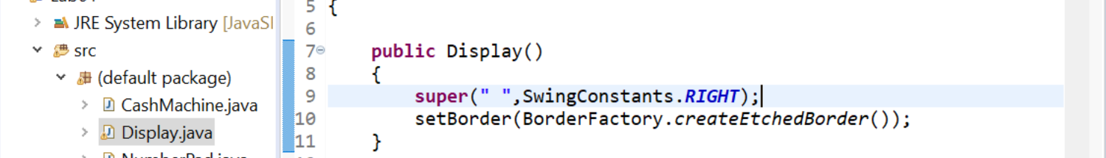

**5-7.** Now, modify the Display so that: 1. The "Del" button works as expected. 2. When the Display is empty it displays the text "Enter your PIN". 3. When the Display is not empty it shows (an appropriate number of) asterisks rather than the PIN. What code is in your Display class now?

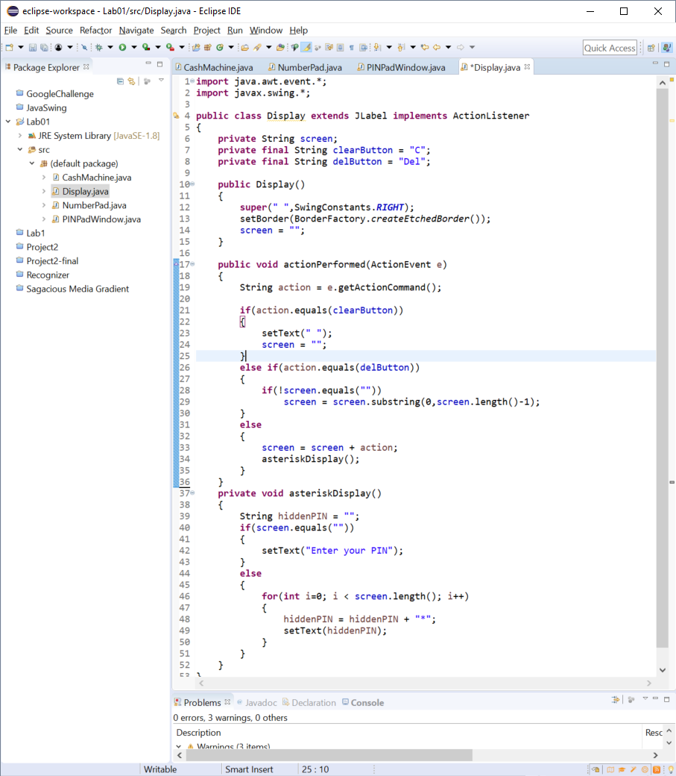

**5-8.** Now, modify the Display so that the text is gray when "Enter your PIN" is displayed and red when the asterisks are displayed. What code did you change?

